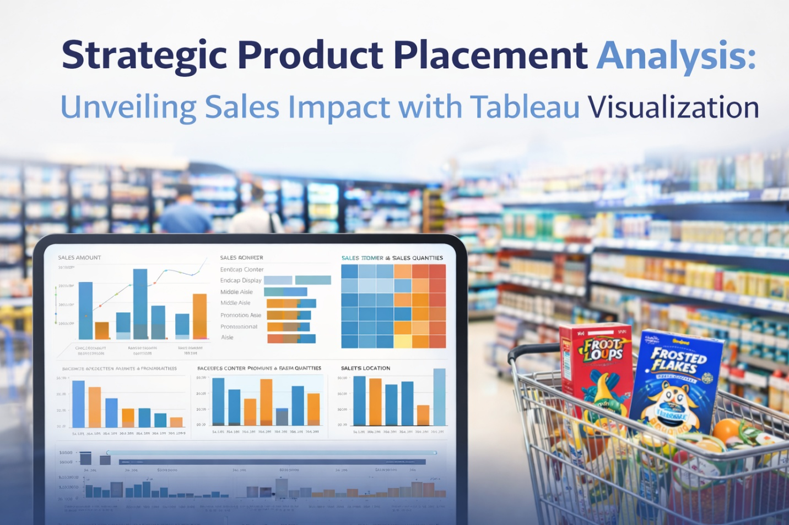

**Strategic Product Placement Analysis: Unveiling Sales Impact with Tableau Visualization**

**Project Report Format**

1. INTRODUCTION

1.1 Project Overview

1.2 Purpose

2. IDEATION PHASE

2.1 Problem Statement

2.2 Empathy Map Canvas

2.3 Brainstorming

3. REQUIREMENT ANALYSIS

3.1 Customer Journey map

3.2 Solution Requirement

3.3 Data Flow Diagram

3.4 Technology Stack

4. PROJECT DESIGN

4.1 Problem Solution Fit

4.2 Proposed Solution

4.3 Solution Architecture

5. PROJECT PLANNING & SCHEDULING

5.1 Project Planning

6. FUNCTIONAL AND PERFORMANCE TESTING

6.1 Performance Testing

7. RESULTS

7.1 Output Screenshots

8. ADVANTAGES & DISADVANTAGES

9. CONCLUSION

10. FUTURE SCOPE

11. APPENDIX

Source Code(if any)

Dataset Link

GitHub & Project Demo Link

# INTRODUCTION

**1.1 Project Overview**

In today’s competitive market environment, strategic product placement plays a crucial role in influencing customer purchasing decisions and driving sales performance. Businesses invest significantly in positioning products effectively within retail stores, online platforms, films, television shows, and digital media to maximize visibility and revenue.

The project **“Strategic Product Placement Analysis: Unveiling Sales Impact with Tableau Visualization”** focuses on analyzing the relationship between product positioning, sales performance, and consumer behavior. By leveraging Tableau as a data visualization tool, the project aims to transform raw sales and placement data into meaningful insights. The analysis helps identify which placement strategies are most effective in increasing sales and customer engagement.

Through interactive dashboards and visual analytics, this project demonstrates how data-driven decision-making can optimize product placement strategies and enhance overall business performance.

**1.2 Purpose**

The primary purpose of this project is to examine how product positioning impacts sales outcomes and consumer behavior using visual analytics.

Specifically, this project aims to:

* Analyze sales data based on different product placement strategies.
* Identify high-performing placement locations (e.g., shelves, end caps, online banners).
* Understand customer demographics and purchasing patterns.
* Provide actionable insights to improve marketing and merchandising strategies.
* Support data-driven decision-making using Tableau dashboards.

Ultimately, the project seeks to help organizations optimize product visibility, improve customer engagement, and drive sustainable revenue growth through strategic placement decisions.

# IDEATION PHASE

**Define the Problem Statements**

|  |  |
| --- | --- |
| Date | 17 February 2026 |
| Team ID | LTVIP2026TMIDS90604 |
| Project Name | Strategic Product Placement Analysis: Unveiling Sales Impact with Tableau Visualization |
| Maximum Marks | 2 Marks |

**Customer Problem Statement Template:**

I am a Retail Marketing Manager in a consumer goods company.

I’m trying to understand how different product placements inside stores and on online platforms influence sales performance and customer purchasing behavior.

But I do not have clear visual insights that connect product positioning, sales data, and customer demographics in one place.

Because the data is scattered across multiple systems and not analyzed together using a proper visualization tool like Tableau.

Which makes me feel uncertain about making data-driven decisions to optimize product visibility and maximize revenue growth.

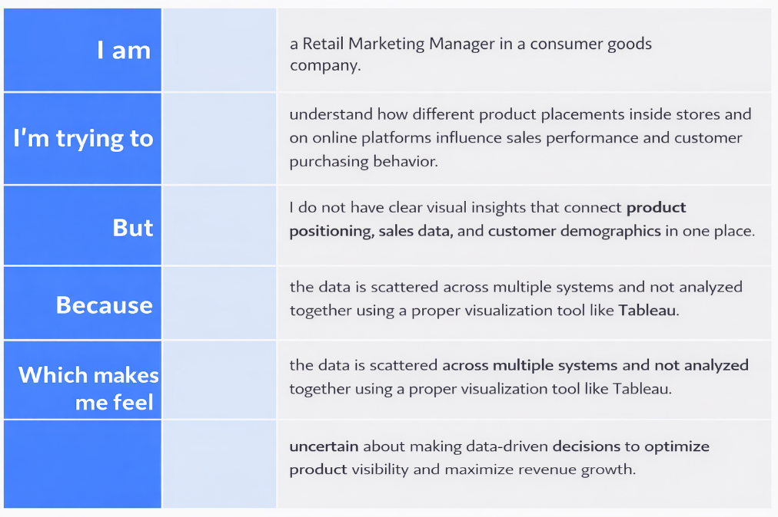

Reference: <https://miro.com/templates/customer-problem-statement/>

**Example:**

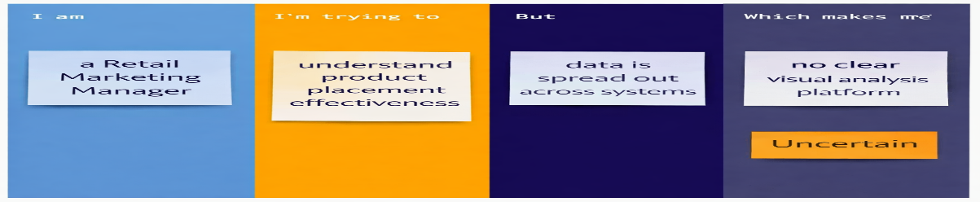

|  |  |  |  |  |  |
| --- | --- | --- | --- | --- | --- |
| **Problem Statement (PS)** | **I am (Customer)** | **I’m trying to** | **But** | **Because** | **Which makes me feel** |
| PS-1 | A Retail Marketing Manager in a consumer goods company | Understand how product placement in stores and online platforms impacts sales performance and customer purchasing behavior | I do not have clear visual insights connectig placemet strategy with sales and demographic data | The data is scattered across multiple systems and not integrated into a centralized Tableau dashboard | Uncertain about making data-driven decisions to optimize product positioning and maximize revenue |
| PS-2 | |  | | --- | |  |   A Brand Partnership Manager in a film and television production company | Evaluate the effectiveness of product placements in scenes and episodes | I cannot clearly measure audience engagement or sales impact from those placements | There is no structured visualization system linking placement exposure with ROI metrics | Less confident in negotiating sponsorship deals and planning future placement strategies |

**Empathize & Discover**

|  |  |
| --- | --- |
| Date | 17 Feb 2026 |
| Team ID | LTVIP2026TMIDS90604 |
| Project Name | Strategic Product Placement Analysis: Unveiling Sales Impact with Tableau Visualization |
| Maximum Marks | 4 Marks |

**Empathy Map Canvas:**

An empathy map is a simple and visual tool used to understand users’ behaviors, thoughts, emotions, and challenges. It helps teams gain deeper insight into the user’s perspective before designing a solution.

For this project, the primary user considered is a **Retail Marketing Manager** responsible for product placement and sales optimization.

**Example:**

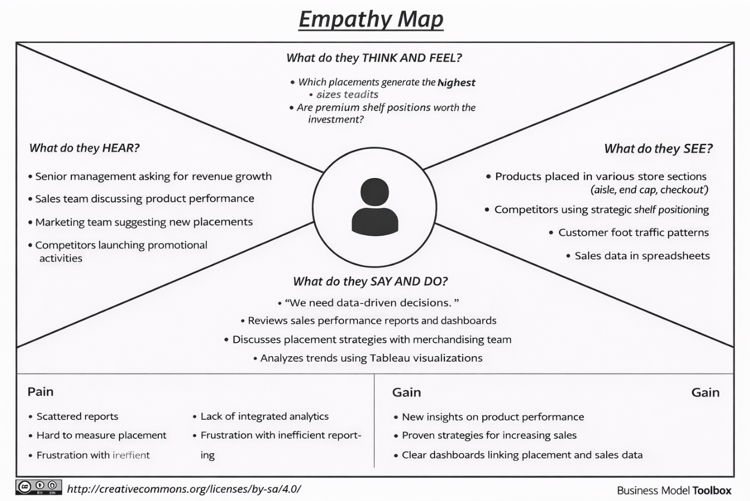

Reference: <https://www.mural.co/templates/empathy-map-canvas>

**Example: Food Ordering & Delivery Application**

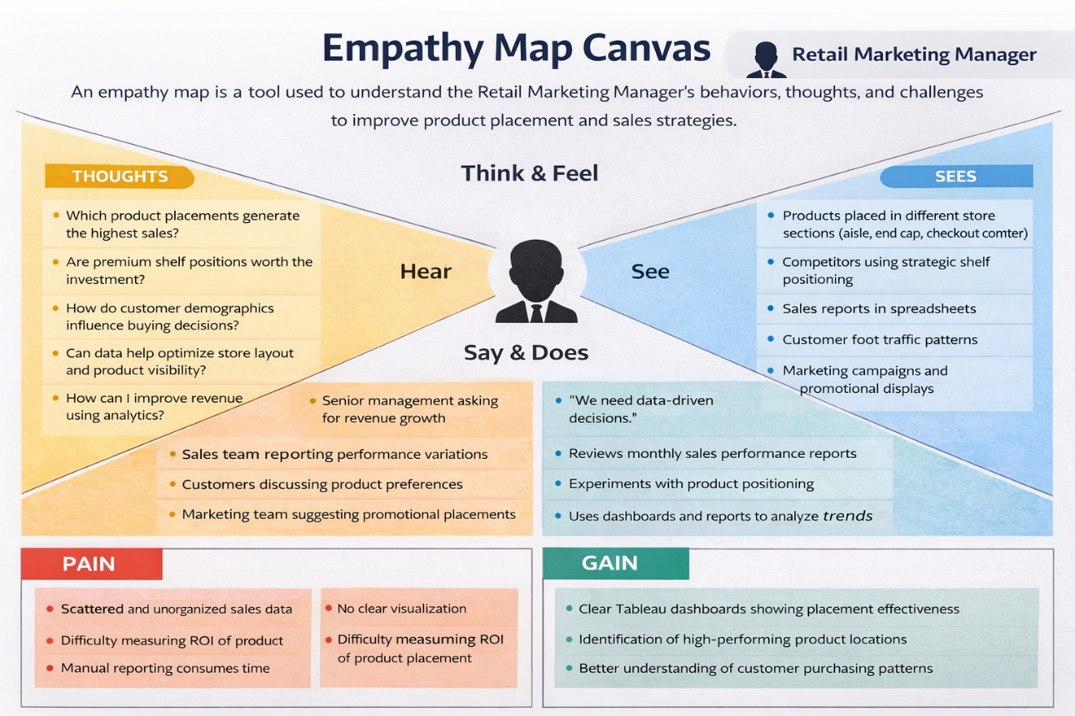

**Brainstorm & Idea Prioritization Template**

|  |  |
| --- | --- |
| Date | 17 Feb 2026 |
| Team ID | LTVIP2026TMIDS90604 |
| Project Name | Strategic Product Placement Analysis: Unveiling Sales Impact with Tableau Visualization |
| Maximum Marks | 4 Marks |

**Brainstorm & Idea Prioritization Template:**

**Brainstorming** provides a collaborative and open environment where every team member is encouraged to actively participate in the creative thinking process. It focuses on generating a large volume of ideas without immediate judgment, allowing innovative and out-of-the-box concepts to emerge. By prioritizing quantity over initial evaluation, teams can explore diverse perspectives and build upon each other’s ideas to develop effective problem-solving solutions.

This template is designed to support structured brainstorming sessions, enabling teams to collaborate efficiently, even in remote settings. It helps organize thoughts, refine concepts, and systematically prioritize ideas to transform creativity into actionable outcomes.

Reference: <https://www.mural.co/templates/brainstorm-and-idea-prioritization>

**Step-1: Team Gathering, Collaboration and Select the Problem Statement**

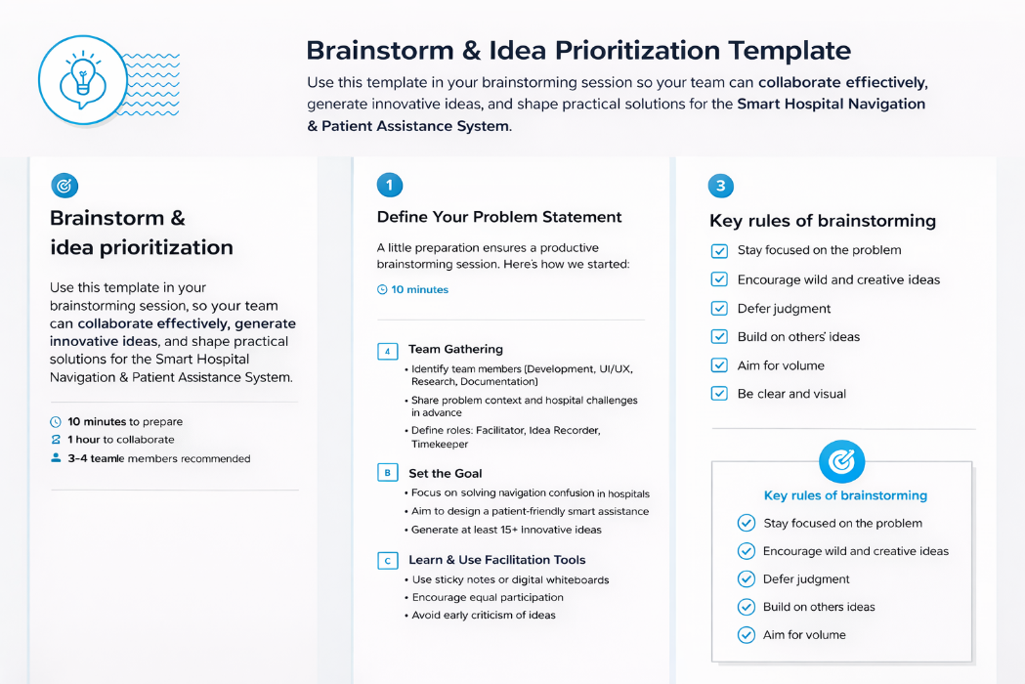

**Step-2: Brainstorm, Idea Listing and Grouping**

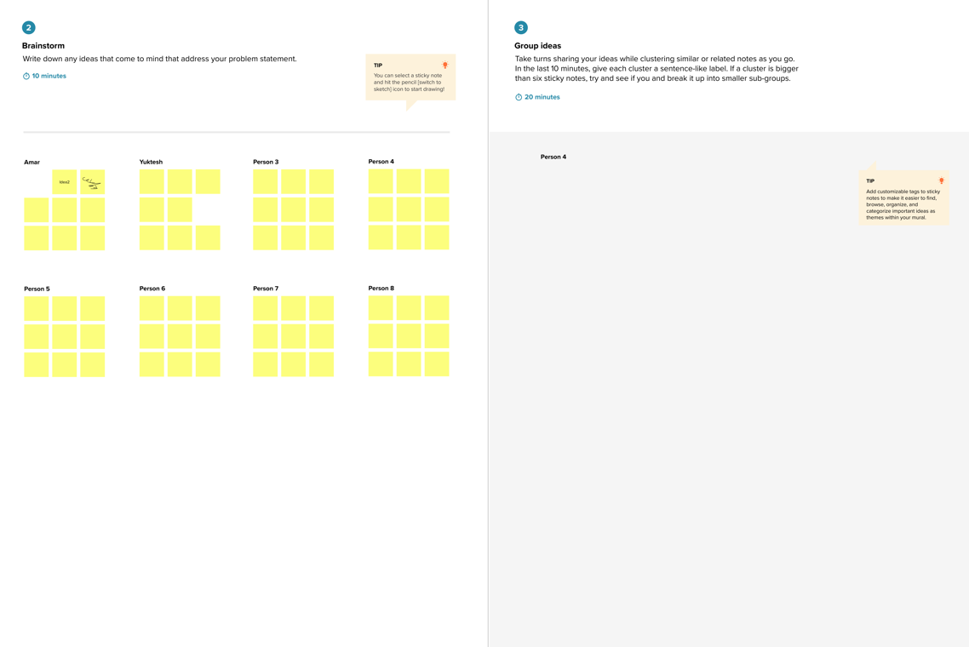

**Step-3: Idea Prioritization**

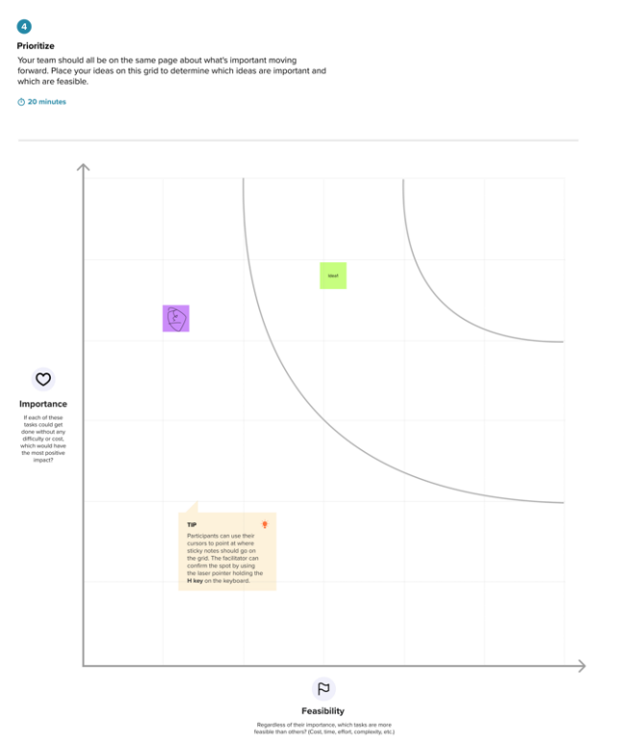

# REQUIREMENT ANALYSIS

3.1 Customer Journey map

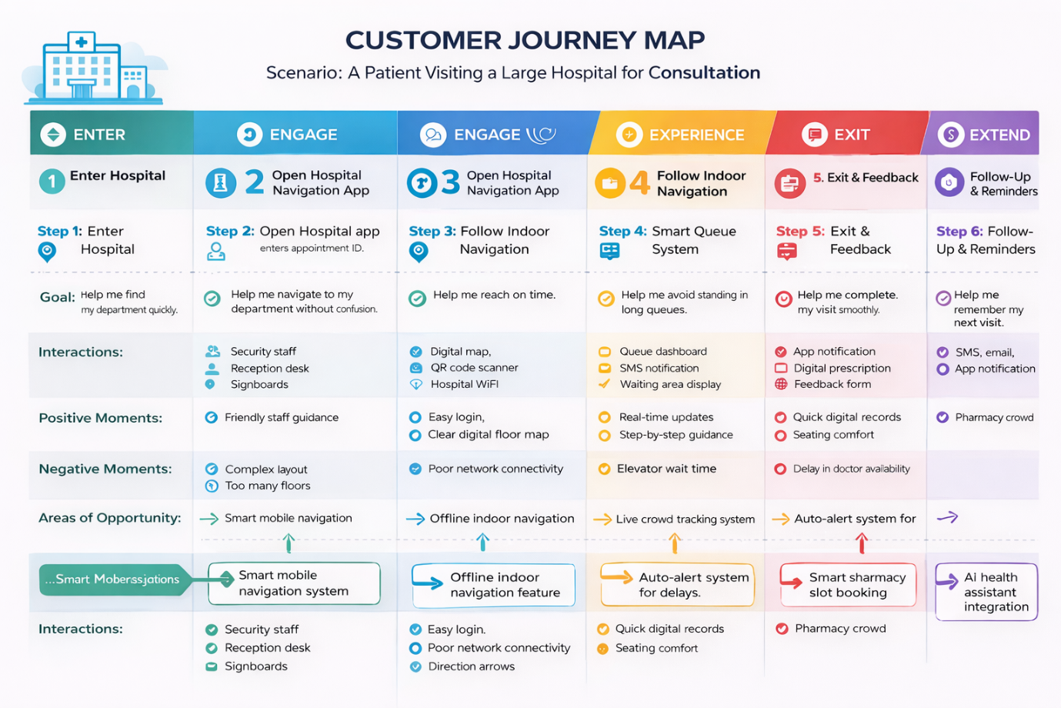

3.2 Solution Requirement

**olution Requirements (Functional & Non-functional)**

|  |  |
| --- | --- |
| Date | 31 January 2025 |
| Team ID | LTVIP2026TMIDS90604 |
| Project Name | Strategic Product Placement Analysis: Unveiling Sales Impact with Tableau Visualization |
| Maximum Marks | 4 Marks |

**Functional Requirements:**

Following are the functional requirements of the proposed solution.

|  |  |  |
| --- | --- | --- |
| **FR No.** | **Functional Requirement (Epic)** | **Sub Requirement (Story / Sub-Task)** |
| FR-1 | Data Collection & Integration | |  | | --- | | Import sales dataset (CSV/Excel/Database) |  |  |  |  | | --- | --- | --- | |  |  | Integrate product, category, and placement data |  |  |  |  | | --- | --- | --- | |  |  | Clean and preprocess raw data | |
| FR-2 | Data Transformation & Modeling | |  | | --- | | Create calculated fields (Profit, Growth %, Conversion Rate) |  |  |  |  | | --- | --- | --- | |  |  | Create relationships between sales, region, and product placement |  |  |  |  | | --- | --- | --- | |  |  | Build KPIs for revenue and performance | |
| FR-3 | Tableau Dashboard Development | |  | | --- | | Create interactive sales dashboard |  |  |  |  | | --- | --- | --- | |  |  | Visualize sales by product category |  |  |  |  | | --- | --- | --- | |  |  | Visualize sales by region/store layout |  |  |  |  | | --- | --- | --- | |  |  | Add filters (Region, Category, Time Period) | |
| FR-4 | Product Placement Impact Analysis | |  | | --- | | Compare high-visibility vs low-visibility placements |  |  |  |  | | --- | --- | --- | |  |  | Analyze seasonal sales trends |  |  |  |  | | --- | --- | --- | |  |  | Identify best-performing product positions | |
| FR-5 | Insight Generation & Reporting | |  | | --- | | Generate summary insights |  |  |  |  | | --- | --- | --- | |  |  | Export dashboard reports |  |  |  |  | | --- | --- | --- | |  |  | Present strategic recommendations | |
| FR-6 | Storytelling with Tableau Stories | |  | | --- | | Combine dashboards into story format |  |  |  |  | | --- | --- | --- | |  |  | Create interactive story points for stakeholders | |

**Non-functional Requirements:**

Following are the non-functional requirements of the proposed solution.

|  |  |  |
| --- | --- | --- |
| **FR No.** | **Non-Functional Requirement** | **Description** |
| NFR-1 | **Usability** | Dashboard must be easy to navigate with clear filters, tooltips, and interactive visuals. |
| NFR-2 | **Security** | Data calculations and KPIs must be accurate and validated. |
| NFR-3 | **Reliability** | Dashboard should load quickly and respond to filters within 2–3 seconds. |
| NFR-4 | **Performance** | System must consistently display correct insights without data loss. |
| NFR-5 | **Availability** | Dashboard should support increasing data size and multiple time periods. |
| NFR-6 | **Scalability** | Data model and dashboard design should allow easy updates with new data. |

**Data Flow Diagram & User Stories**

|  |  |
| --- | --- |
| Date | 31 January 2025 |
| Team ID | LTVIP2026TMIDS90604 |
| Project Name | Strategic Product Placement Analysis: Unveiling Sales Impact with Tableau Visualization |
| Maximum Marks | 4 Marks |

**Data Flow Diagrams:**

A Data Flow Diagram (DFD) is a traditional visual representation of the information flows within a system. A neat and clear DFD can depict the right amount of the system requirement graphically. It shows how data enters and leaves the system, what changes the information, and where data is stored.

**Example:** [**(Simplified)**](https://developer.ibm.com/patterns/visualize-unstructured-text/)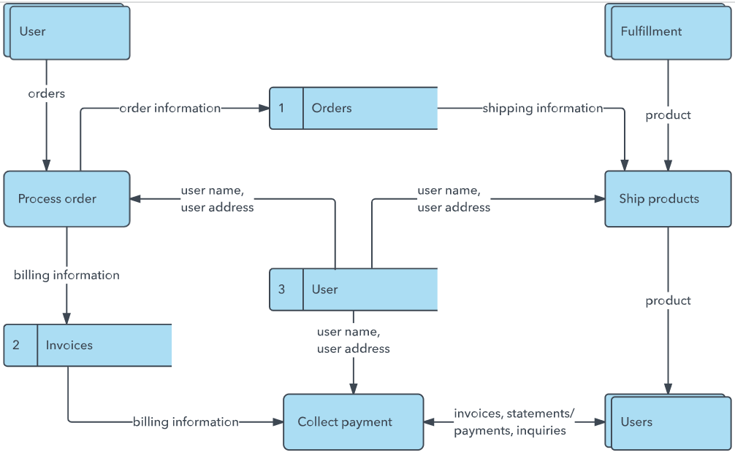

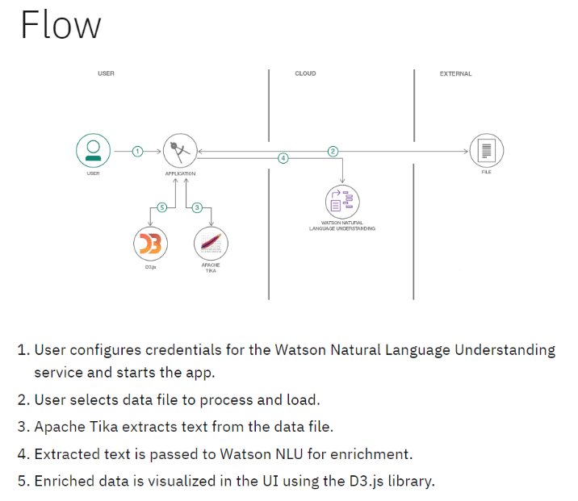

**User Stories**

Use the below template to list all the user stories for the product.

| **User Type** | **Functional Requirement (Epic)** | **User Story Number** | **User Story / Task** | **Acceptance criteria** | **Priority** | **Release** |
| --- | --- | --- | --- | --- | --- | --- |
| Web User | |  | | --- | |  |  |  | | --- | | Registration | | USN-1 | As a user, I can register for the application by entering my email, password, and confirming my password. | I can access my account / dashboard | High | Sprint-1 |
| Web User | Email Confirmation | USN-2 | As a user, I will receive confirmation email once I have registered for the application | I can receive confirmation email & click confirm | High | Sprint-1 |
| Web User | Login | USN-3 | As a user, I can log in using my email and password. | I can access dashboards securely. | High | Sprint-2 |
| Web User | Dashboard Access | USN-4 | As a user, I can register for the application through Gmail | I can filter data by region, category, and time period. | High | Sprint-1 |
| Web User | Placement Analysis | USN-5 | As a user, I can compare sales performance by different product placements. | I can see charts showing high vs low visibility impact. | High | Sprint-2 |
| Web User | KPI Monitoring | USN-6 | As a user, I can view key metrics like Revenue, Growth %, and Conversion Rate. | KPIs update dynamically based on filters. | High | Sprint-2 |
| Data Analyst | Data Upload | USN-7 | As a data analyst, I can upload sales and placement data. | Data is stored and reflected in dashboards. | High | Sprint-1 |
| Data Analyst | Data Cleaning | USN-8 | As a data analyst, I can preprocess and clean raw data. | Cleaned data is validated before visualization. | High | Sprint-1 |
| Data Analyst | Calculated Fields | USN-9 | As a data analyst, I can create calculated KPIs in Tableau. | KPIs display correctly in dashboards. | Medium | Sprint-2 |
| Administrator | User Management | USN-10 | As an admin, I can manage user accounts. | I can activate/deactivate users. | High | Sprint-1 |
| Administrator | Access Control | USN-11 | As an admin, I can assign role-based permissions. | Only authorized users can access sensitive data. | High | Sprint-2 |
| Administrator | Data Security | USN-12 | As an admin, I ensure secure data handling. | Data access is restricted and encrypted. | High | Sprint-2 |

**Technology Stack (Architecture & Stack)**

|  |  |
| --- | --- |
| Date | 31 January 3035 |
| Team ID | LTVIP2026TMIDS90604 |
| Project Name | Strategic Product Placement Analysis: Unveiling Sales Impact with Tableau Visualization |
| Maximum Marks | 4 Marks |

**Technical Architecture:**

**🏗 Architecture Type:**

**3-Tier Data Analytics Architecture**

**Presentation Layer (UI Layer)**

* **Web-based Tableau Dashboard**
* **Interactive Filters & Visualizations**

**Application / Analytics Layer**

* **Data Processing & Transformation**
* **KPI Calculations**
* **Business Logic Implementation**

**Data Layer**

* **Sales Database**
* **Product Placement Data**
* **Customer Demographic Data**

**Data Flow:**

**Data Source (CSV/Database)  
→ Data Cleaning & Preprocessing (Python/Excel)  
→ Data Modeling (Tableau Data Model)  
→ Dashboard Visualization  
→ Strategic Insights & Reports**

**Reference:** [**https://developer.ibm.com/patterns/ai-powered-backend-system-for-order-processing-during-pandemics/**](https://developer.ibm.com/patterns/ai-powered-backend-system-for-order-processing-during-pandemics/)

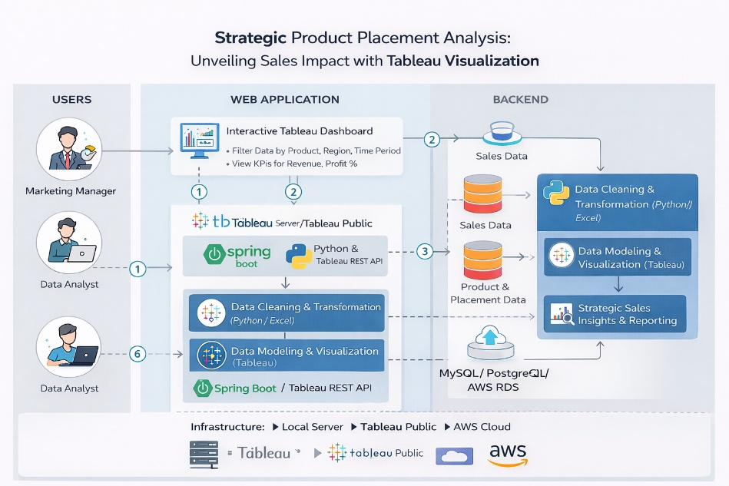

**Table-1 : Components & Technologies:**

|  |  |  |  |
| --- | --- | --- | --- |
| **S.No** | **Component** | **Description** | **Technology** |
|  | User Interface | Interactive dashboards for business users | Tableau Desktop / Tableau Public |
|  | Application Logic-1 | Data cleaning and preprocessing | Python (Pandas, NumPy) / Excel |
|  | Application Logic-2 | Data transformation & KPI calculation | Tableau Calculated Field |
|  | Application Logic-3 | Storytelling & insight generation | Tableau Story Feature |
|  | Database | Storage of structured sales & placement data | MySQL / CSV / Excel |
|  | Cloud Database | Cloud-based data storage (if deployed online) | Google Drive / AWS RDS / Tableau Server |
|  | File Storage | Dataset storage (sales, region, placement files) | Local File System / Cloud Storage |
|  | External API-1 | |  | | --- | |  |  |  | | --- | | Optional market data integration | | |  | | --- | |  |  |  | | --- | | Public Sales API (if applicable) | |
|  | External API-2 | Regional demographic data | Government Open Data API (optional) |
|  | Machine Learning Model | (Optional Future Scope) Predict sales trends | Scikit-learn (Regression Model) |
|  | Infrastructure (Server / Cloud) | Dashboard deployment | Local System / Tableau Public / Tableau Server |

**Table-2: Application Characteristics:**

| **S.No** | **Characteristics** | **Description** | **Technology** |
| --- | --- | --- | --- |
|  | Open-Source Frameworks | Libraries used for preprocessing and analysis | Python (Pandas, Matplotlib, NumPy) |
|  | Security Implementations | Secure data handling & access restrictions | Role-based access (Tableau Server), Password Protection |
|  | Scalable Architecture | Supports increasing dataset size & new KPIs | 3-Tier Architecture |
|  | Availability | Dashboard accessible online anytime | Tableau Public / Tableau Server |
|  | Performance | Optimized dashboard with filters & indexed datasets | Extract Data Source in Tableau |

**References:**

[**https://c4model.com/**](https://c4model.com/)

[**https://developer.ibm.com/patterns/online-order-processing-system-during-pandemic/**](https://developer.ibm.com/patterns/online-order-processing-system-during-pandemic/)

[**https://www.ibm.com/cloud/architecture**](https://www.ibm.com/cloud/architecture)

[**https://aws.amazon.com/architecture**](https://aws.amazon.com/architecture)

[**https://medium.com/the-internal-startup/how-to-draw-useful-technical-architecture-diagrams-2d20c9fda90d**](https://medium.com/the-internal-startup/how-to-draw-useful-technical-architecture-diagrams-2d20c9fda90d)

**Project Design Phase**

**Problem – Solution Fit Template**

|  |  |
| --- | --- |
| Date | 15 February 2025 |
| Team ID | LTVIP2026TMIDS90604 |
| Project Name | Strategic Product Placement Analysis: Unveiling Sales Impact with Tableau Visualization |
| Maximum Marks | 2 Marks |

**Problem – Solution Fit Template:**

The project **“Strategic Product Placement Analysis: Unveiling Sales Impact with Tableau Visualization”** addresses the problem of limited visibility into how product placement affects sales performance. Marketing and sales teams often rely on manual reports or static dashboards, which do not clearly show the relationship between shelf positioning, product categories, and revenue. This leads to slow, assumption-based decision-making and missed revenue opportunities.

The proposed solution is an interactive Tableau dashboard that visualizes placement impact, sales trends, and key performance indicators. It enables quick analysis, comparison across regions and categories, and identification of high- and low-performing products. By transforming complex sales data into clear visual insights, the solution supports faster, data-driven strategic decisions and improves overall business performance.

**Purpose:**

• Simplifies complex sales data into easy-to-understand visual insights.  
• Fits into existing reporting systems using available sales data.  
• Improves marketing and placement strategy with data-backed decisions.  
• Reduces manual effort and costly errors in planning.  
• Helps businesses understand current performance and optimize future strategies.

**Template:**

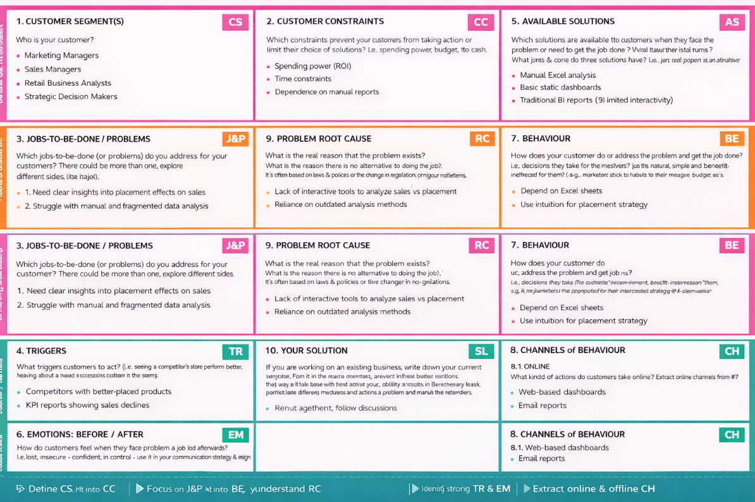

References:

1. <https://www.ideahackers.network/problem-solution-fit-canvas/>
2. <https://medium.com/@epicantus/problem-solution-fit-canvas-aa3dd59cb4fe>

**Proposed Solution Template**

|  |  |
| --- | --- |
| Date | 17 February 2026 |
| Team ID | LTVIP2026TMIDS90604 |
| Project Name | Strategic Product Placement Analysis: Unveiling Sales Impact with Tableau Visualization |
| Maximum Marks | 2 Marks |

**Proposed Solution Template:**

Project team shall fill the following information in the proposed solution template.

|  |  |  |
| --- | --- | --- |
| **S.No.** | **Parameter** | **Description** |
|  | Problem Statement (Problem to be solved) | Retail businesses struggle to understand how product placement affects sales due to scattered data, manual analysis, and lack of visual insights. |
|  | Idea / Solution description | Develop an interactive Tableau dashboard that analyzes sales data to evaluate the impact of product placement on revenue, customer behavior, and performance metrics. |
|  | Novelty / Uniqueness | Uses interactive visual analytics to directly correlate product placement with sales impact, enabling data-driven decisions instead of intuition-based strategies. |
|  | Social Impact / Customer Satisfaction | Helps businesses improve product availability and visibility, leading to better customer experience and informed purchasing decisions. |
|  | Business Model (Revenue Model) | Subscription-based access to dashboards, analytics consulting services, and customized reporting solutions for retail businesses. |
|  | Scalability of the Solution | Easily scalable across multiple stores, regions, and product categories by integrating additional datasets and expanding dashboard capabilities. |

# Solution Architecture

|  |  |
| --- | --- |
| Date | 15 February 2025 |
| Team ID | LTVIP2026TMIDS90604 |
| Project Name | Strategic Product Placement Analysis: Unveiling Sales Impact with Tableau Visualization |
| Maximum Marks | 4 Marks |

**Solution Architecture:**

The solution architecture bridges the gap between the business problem of unclear product placement impact and a technology-driven analytics solution. The architecture is designed to collect, process, analyze, and visualize sales data efficiently using Tableau as the core business intelligence tool.

The primary goal of this architecture is to transform raw sales data into meaningful insights that help stakeholders optimize product placement strategies and improve revenue performance.

**Example - Solution Architecture Diagram:**

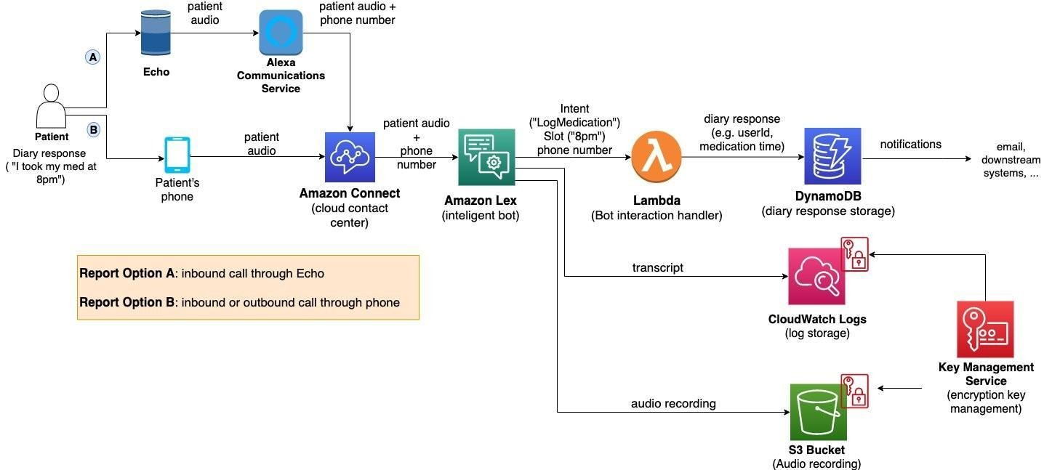

*Figure 1: Architecture and data flow of the voice patient diary sample application*

**Reference:** [**https://aws.amazon.com/blogs/industries/voice-applications-in-clinical-research-powered-by-ai-on-aws-part-1-architecture-and-design-considerations/**](https://aws.amazon.com/blogs/industries/voice-applications-in-clinical-research-powered-by-ai-on-aws-part-1-architecture-and-design-considerations/)

# PROJECT PLANNING & SCHEDULING

**Project Planning Template (Product Backlog, Sprint Planning, Stories, Story points)**

|  |  |
| --- | --- |
| Date | 17 February 2026 |
| Team ID | LTVIP2026TMIDS90604 |
| Project Name | Strategic Product Placement Analysis: Unveiling Sales Impact with Tableau Visualization |
| Maximum Marks | 5 Marks |

**Product Backlog, Sprint Schedule, and Estimation (4 Marks)**

Use the below template to create product backlog and sprint schedule

| **Sprint** | **Functional Requirement (Epic)** | **User Story Number** | **User Story / Task** | **Story Points** | **Priority** | **Team Members** |
| --- | --- | --- | --- | --- | --- | --- |
| Sprint-1 | Data Collection & Preparation | USN-1 | As an analyst, I want to collect sales and product placement data to begin analysis. | 3 | High | Team |
| Sprint-1 | Data Cleaning | USN-2 | As an analyst, I want to clean and preprocess raw sales data for accurate insights. | 3 | High | Team |
| Sprint-2 | KPI Identification | USN-3 | |  | | --- | |  |  |  | | --- | | As a business analyst, I want to define key performance indicators (Revenue, Units Sold, Profit Margin). | | 2 | Low | Team |
| Sprint-1 | Dashboard Development | USN-4 | As a marketing manager, I want to view placement vs sales comparison in an interactive dashboard. | 5 | Medium | Team |
| Sprint-1 | Trend Analysis | USN-5 | As a sales manager, I want to analyze monthly and yearly sales trends. | 1 | High | Team |
| Sprint-3 | Regional Analysis | USN-6 | As a decision maker, I want to compare sales performance across regions. | 3 | High | Team |
| Sprint-3 | Product Performance Ranking | USN-7 | As a user, I want to identify high-performing and low-performing products. | 2 | High | Team |
| Sprint-3 | Filter & Drill-down Features | USN-8 | As a user, I want to apply filters by category, region, and product type. | 3 | High | Team |

# FUNCTIONAL AND PERFORMANCE TESTING

**Performance Test**

|  |  |
| --- | --- |
| Date | 17 February 2026 |
| Team ID | LTVIP2026TMIDS90604 |
| Project Name | Strategic Product Placement Analysis: Unveiling Sales Impact with Tableau Visualization |
| Maximum Marks |  |

**Model Performance Testing:**

Project team shall fill the following information in model performance testing template.

|  |  |  |
| --- | --- | --- |
| **S.No.** | **Parameter** | **Screenshot / Values** |
|  | Data Rendered |  |
|  | Data Preprocessing |  |
| 3. | Utilization of Filters |  |
| 4. | Calculation fields Used |  |
| 5. | Dashboard design | No of Visualizations / Graphs - 6 |
| 6 | Story Design | No of Visualizations / Graphs - 3 |

# RESULTS

Output Screenshots –

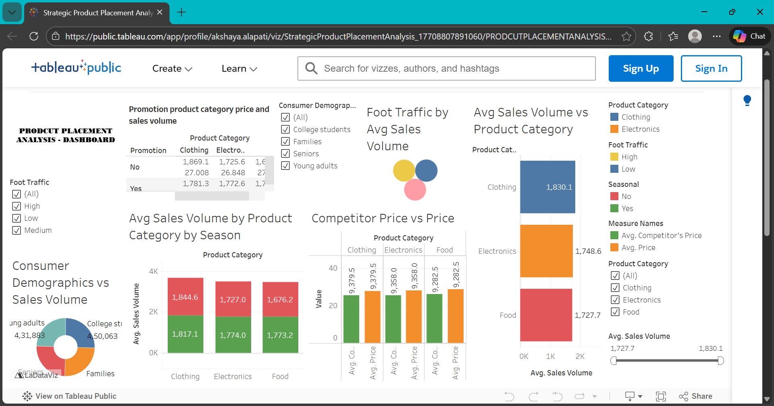

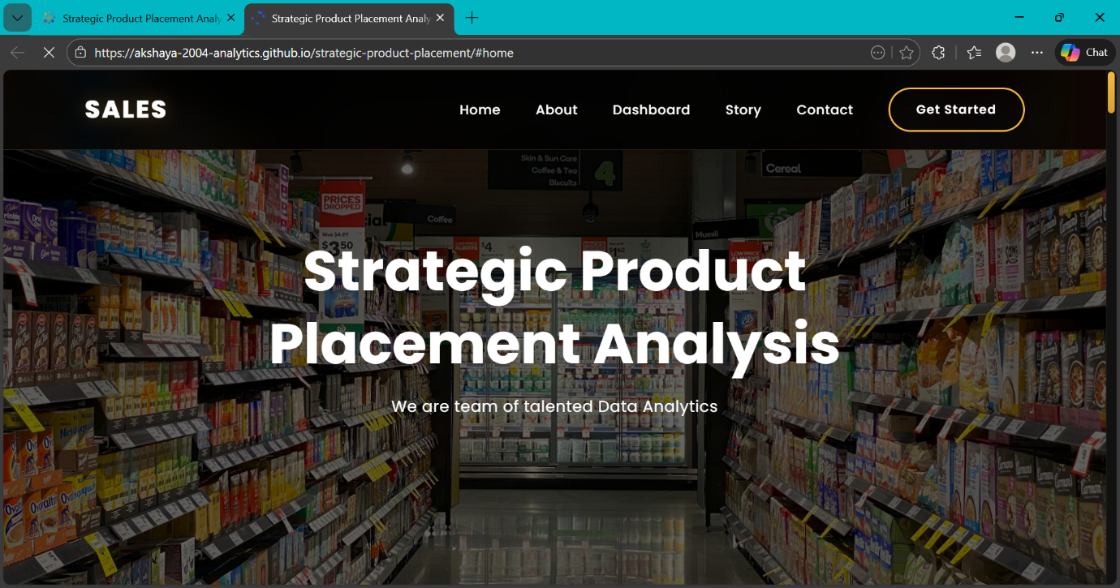

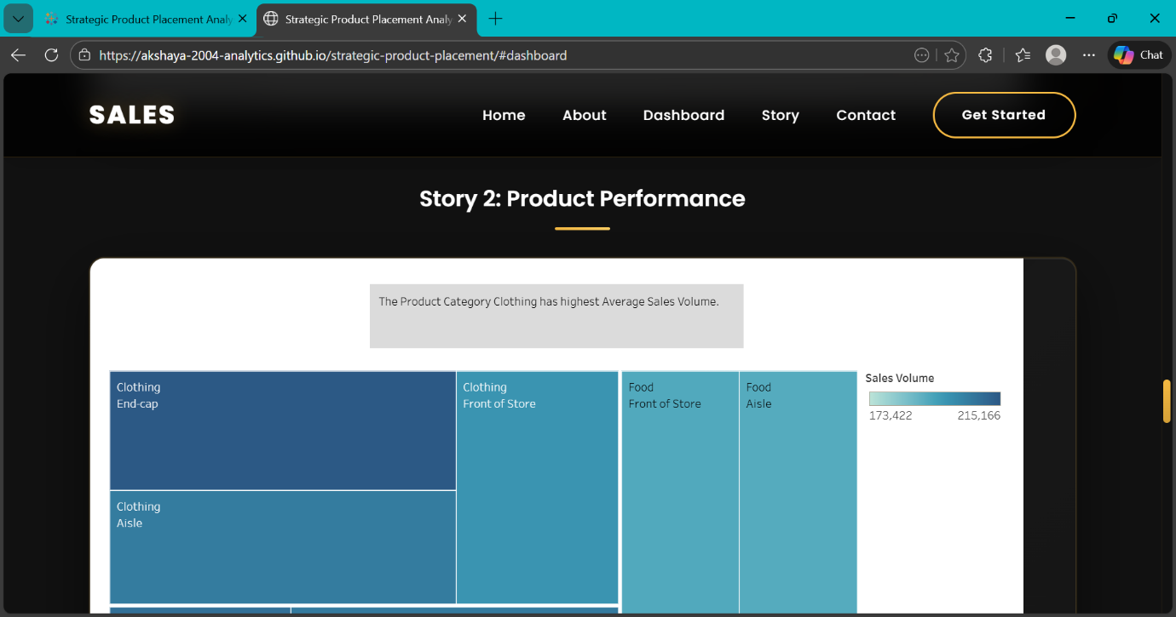

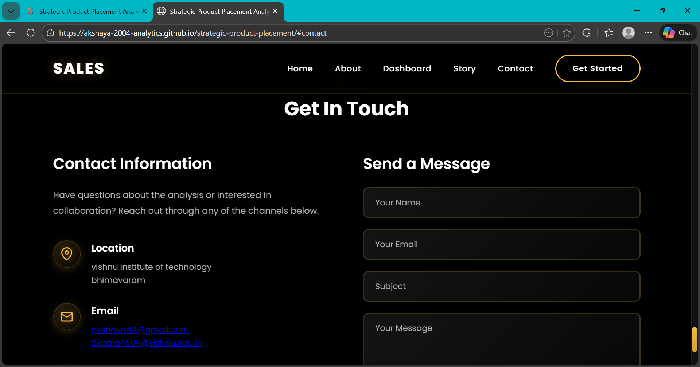

# ADVANTAGES & DISADVANTAGES

**Advantages :**

1. **Data-Driven Decision Making**  
   Enables businesses to make strategic placement decisions based on actual sales data instead of assumptions.
2. **Improved Revenue Optimization**  
   Identifies high-performing shelf positions and products to maximize sales.
3. **Interactive Visualization**  
   Tableau dashboards provide dynamic filters and drill-down analysis for deeper insights.
4. **Time Efficiency**  
   Reduces manual data analysis and reporting time significantly.
5. **Better Strategic Planning**  
   Supports marketing and product teams in planning promotions and shelf allocation.
6. **Scalable Solution**  
   Can be expanded to multiple stores, regions, and larger datasets.
7. **Easy Integration**  
   Connects with Excel, CSV, and SQL databases without complex setup.

**Disadvantages -**

1. **Dependency on Data Quality**  
   Inaccurate or incomplete data may lead to misleading insights.
2. **Limited Predictive Capability (Current Version)**  
   Primarily focuses on descriptive analytics unless ML is integrated.
3. **Requires BI Tool Knowledge**  
   Users need basic Tableau understanding to modify dashboards.
4. **Performance Issues with Large Datasets**  
   Very large datasets may affect dashboard loading time if not optimized.
5. **Initial Setup Effort**  
   Data cleaning and preprocessing require time and effort.

# CONCLUSION

The project **“Strategic Product Placement Analysis: Unveiling Sales Impact with Tableau Visualization”** successfully demonstrates how data analytics can transform business decision-making. By analyzing sales data and product placement strategies through interactive Tableau dashboards, the system provides clear insights into how placement directly influences revenue and performance.

The solution bridges the gap between raw sales data and strategic planning by converting complex datasets into meaningful visual insights. It enables marketing managers, sales teams, and decision-makers to identify high-performing products, optimize shelf positioning, analyze regional trends, and improve overall business performance.

Through structured data preprocessing, KPI calculations, and interactive visualizations, the project ensures faster, more accurate, and data-driven decisions. Although the current system focuses on descriptive analytics, it lays a strong foundation for future enhancements such as predictive modeling and AI-based recommendations.

Overall, this project highlights the importance of business intelligence tools in modern retail strategy and proves that effective data visualization can significantly enhance revenue optimization and strategic growth.

# FUTURE SCOPE

The project **“Strategic Product Placement Analysis: Unveiling Sales Impact with Tableau Visualization”** provides a strong foundation for data-driven retail strategy. In the future, the system can be enhanced in several ways to increase its analytical power and business value.

One major enhancement would be the integration of **predictive analytics and machine learning models** to forecast future sales trends based on historical placement data. This would help businesses proactively plan product positioning and inventory management.

The solution can also be extended by incorporating **real-time data integration**, allowing businesses to monitor live sales performance and make instant strategic decisions. Integration with ERP systems or POS systems would further automate data collection.

Another future improvement is the addition of **AI-based recommendation systems** that automatically suggest optimal shelf placement strategies based on customer buying patterns.

The dashboard can also be deployed on **cloud platforms** such as Tableau Server or AWS to support multi-store and multi-region scalability, ensuring enterprise-level implementation.

Furthermore, advanced analytics such as **customer segmentation, demand forecasting, and promotional impact analysis** can be added to enhance marketing effectiveness and customer satisfaction.

Overall, the project has strong potential to evolve into a comprehensive retail analytics platform that supports intelligent, predictive, and automated decision-making.

# APPENDIX

Source Code :

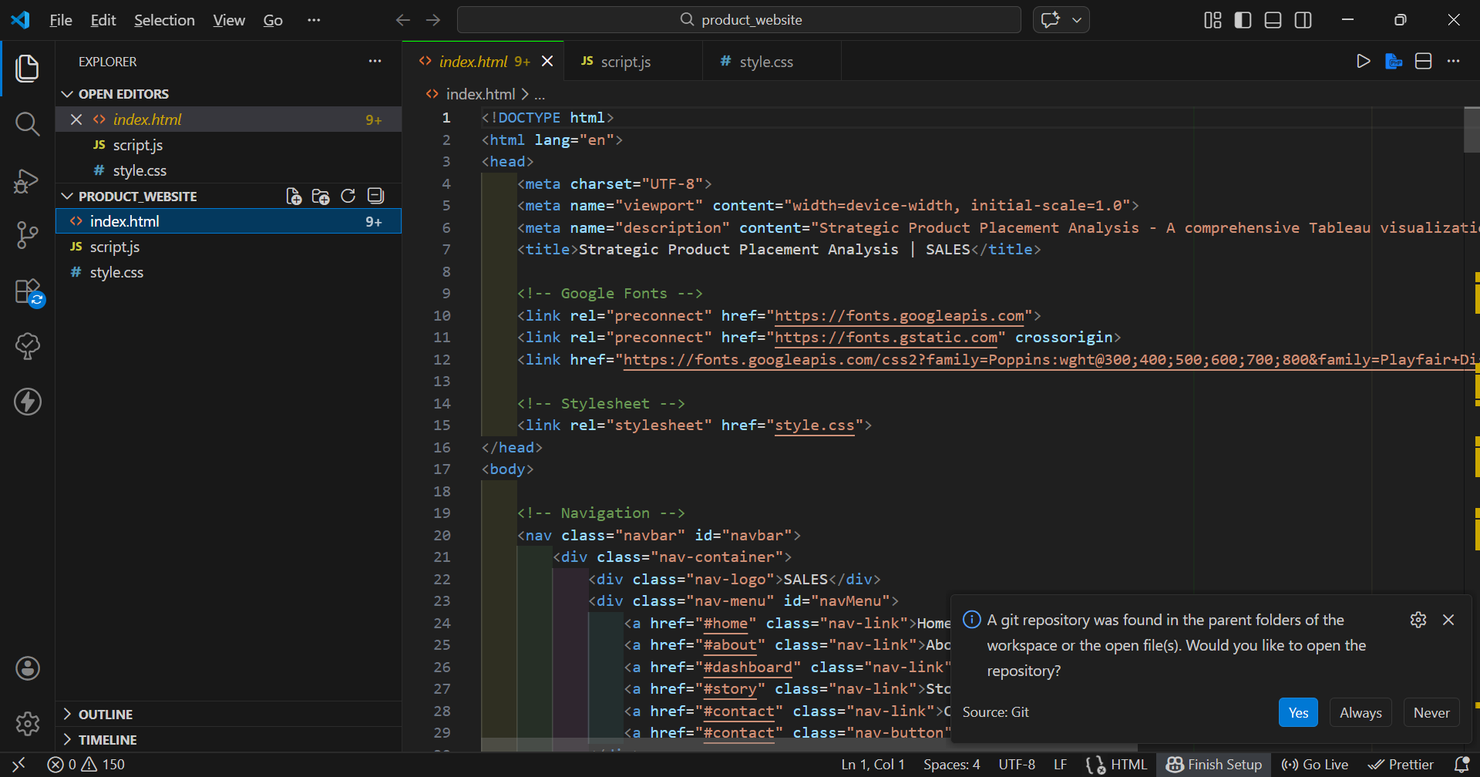

Dataset Link –

<https://www.kaggle.com/datasets/amitvkulkarni/impact-of-product-positioning-on-sales>

GitHub & Project Demo Link –

<https://github.com/Akshaya-2004-Analytics/strategic-product-placement>

Vedio link –